**LAB – 2(Study and implementation of Bit Stuffing and De-stuffing)**

**Bit stuffing** is the insertion of non-information bits into data. Note that stuffed bits should not be confused with overhead bits.

**Applications of Bit Stuffing –**

1. synchronize several channels before multiplexing
2. rate-match two single channels to each other
3. run length limited coding

**Example of bit stuffing –**   
Bit sequence: 110101111101011111101011111110 (without bit stuffing)   
Bit sequence: 1101011111**0**01011111**0**101011111**0**110 (with bit stuffing)

**Implementation of Bit Stuffing in c:**

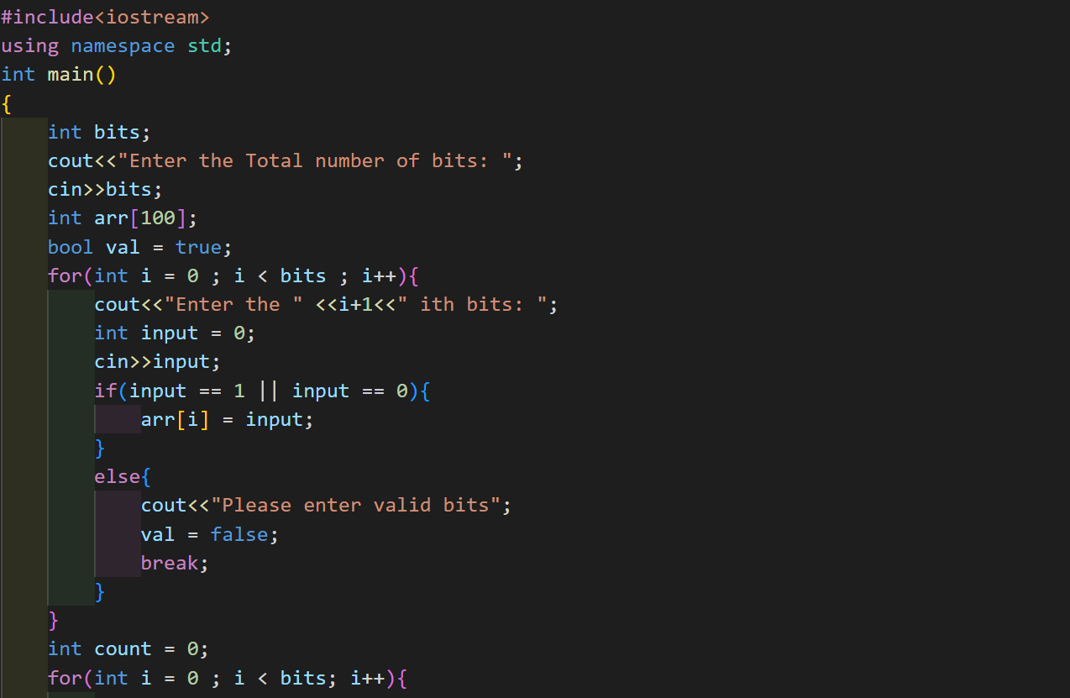

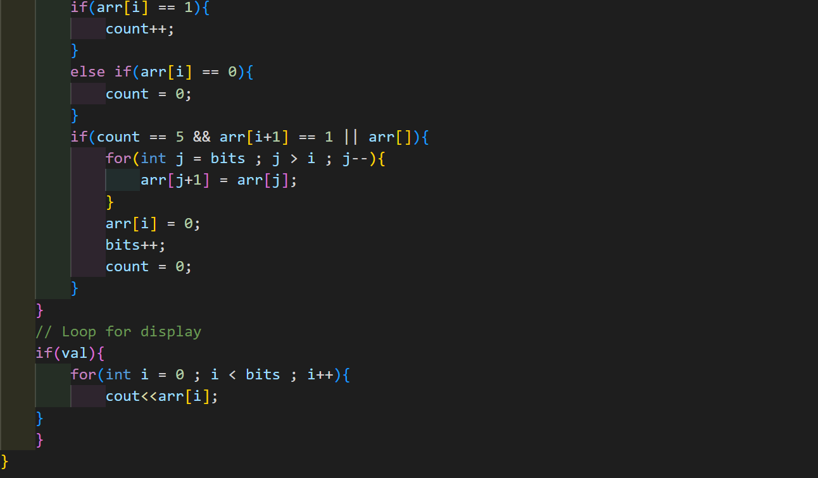

**Output:**

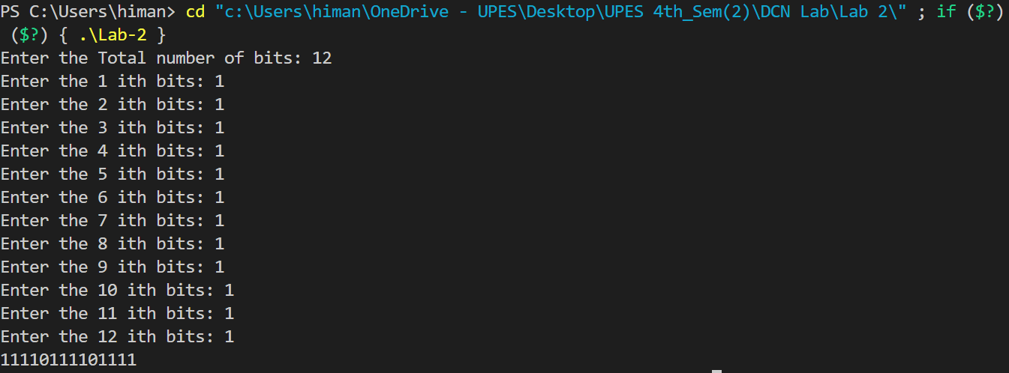

**Bit Destuffing** or **Bit Unstuffing** is a process of undoing the changes in the array made during the [bit stuffing](https://www.geeksforgeeks.org/bit-stuffing-in-computer-network/) process i.e., removing the extra **0** bit after encountering **5** consecutive **1’s**.

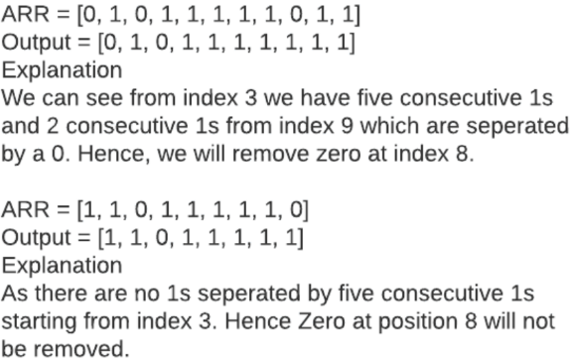

**Implementation of Bit Destuffing in c:**

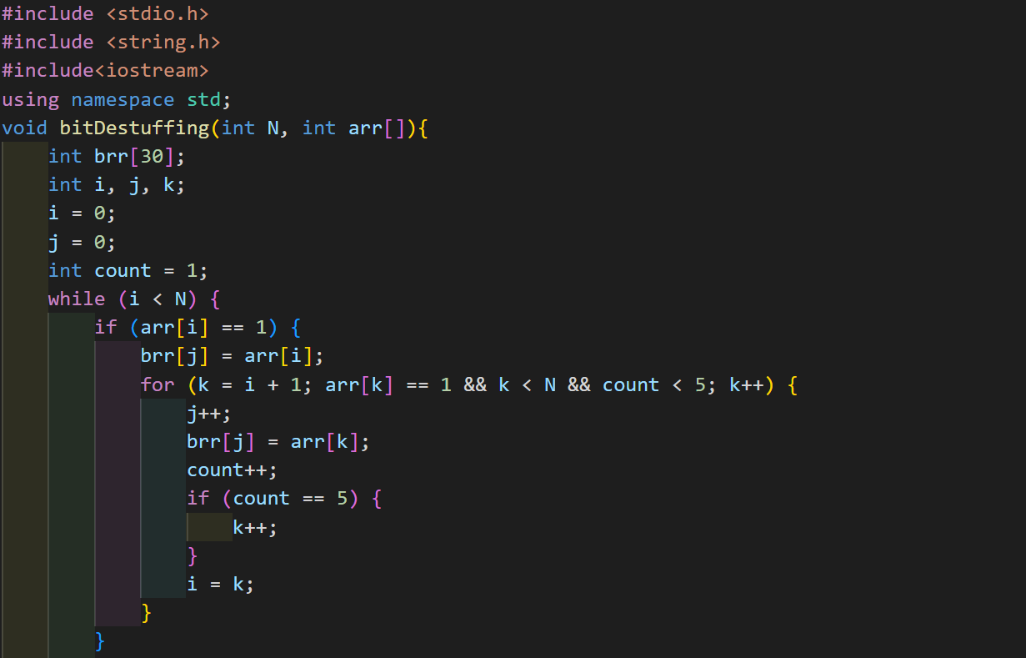

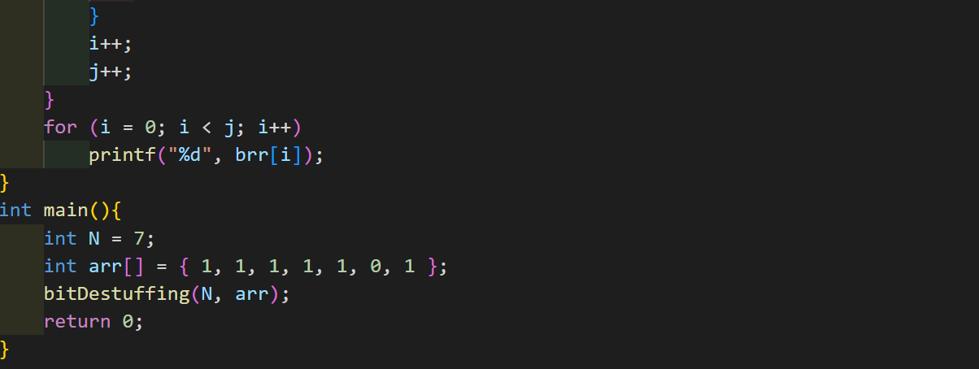

**Output:**

